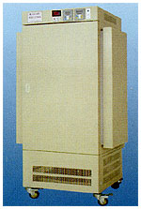 |  |  | 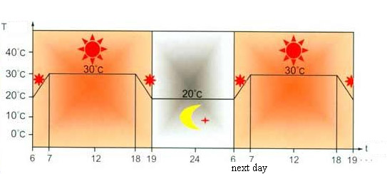  Chart of control zone on temperature and ray radiation
Name | Lighting Incubator |  |  |  | Artificial Climate Incubator
Model No. | RLI-250(S) | RLI-350(S) |  | RLI-450(S) | ACI-250 | ACI-350 | ACI-450
Voltage | 220V 50Hz | 220V 50Hz |  | 220V 50Hz | 220V 50Hz | 380V 50Hz | 380V 50Hz
Temp. Range | 5--45℃ no ray radiation/10--45℃ with ray radiation
Temp. Tolerance | ±1℃ | ±1℃ |  | ±1℃ | ±1℃ | ±1℃ | ±1℃
Humidity Range | ----------- | ----------- |  | ---------- | 50%-95%RH | 50%-95%RH | 50%-95%RH
Humidity Fluctuation | ----------- | ----------- |  | ----------- | ±5%RH | ±5%RH | ±5%RH
Lighting Intensity | >4000Lux | >6000Lux |  | >10000Lux | >4000Lux | >6000Lux | >10000Lux
Power | 1500W | 1800W |  | 2400W | 1750W | 2000W | 2600W
Working Chamber  Dimension | 500×450×1000mm | 600×550×1000mm |  | 600×710×1000mm | 500×450×1000mm | 600×550×1000mm | 600×710×1000mm
S&W ART INCUBATOR

