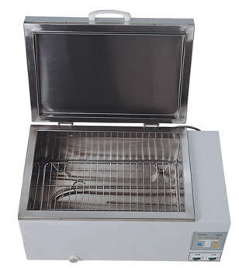
CNW WATERBATH

WB Series Electro-Thermostatic Water Bath
>Working chamber and lid stainless steel.
>Intelligent temperature controller based on microprocessor which can control PID parameters.
>Digital display of set and actual temperatures.
>High accuracy and reliability in controlling temperature.
>Time setting 0-99Hours.
Model No. | Temp. Range | Temp. Tolerance | Voltage | Power | Working Chamber Dimension | Outside Dimension
WB-450B | RT+5℃ ～100℃ | ±0.3℃ | 220V 50HZ | 1500W | 450×300×190mm | 600×340×300mm

