C&W SHAKING WATERBATH
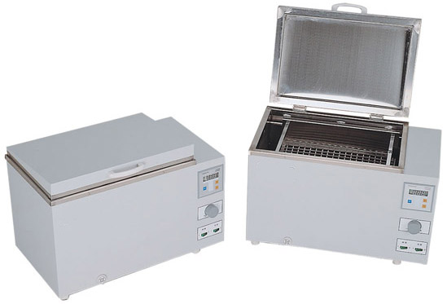
Features
>Stainless steel chamber and lid
>Microprocessor temperature controller
>Digital display of set and actual temperatures.
>Time setting 0-9999min.
Technical Information
Model No. | WBS-450A | WBS-450B | WBS-450C
Voltage | 220V 50Hz | 220V 50Hz | 220V 50Hz
Temp. Range | RT+5℃ ～65℃ | RT+5℃ ～100℃ | 10℃ ～100℃
Temp. Tolerance | ±0.1℃ | ±0.1℃ | ±0.1℃
Power | 1050W | 1250W | 1500W
Shaking Frequency | 0--200 times/min | 0--200 times/min | 30--150 times/min
Amplitude | level 30mm | level 30mm | level 30mm or 40mm
Working Chamber Dimension | 440×300×240mm | 440×300×240mm | 440×300×250mm
Outside Dimension | 620x370x390mm | 620x370x390mm | 643x350x353mm

